**PDA/EDAs For Retail/Warehousing (uncategorized)**

<https://www.alibaba.com/product-detail/Chainway-MC21-Rugged-Pdas-Barcode-Scanner_1600991168324.html?spm=a2700.galleryofferlist.p_offer.d_title.36dc59abPAUBAG&s=p>

Prices: 2 to 9 pieces US$286.00

>= 10 pieces US$275.00

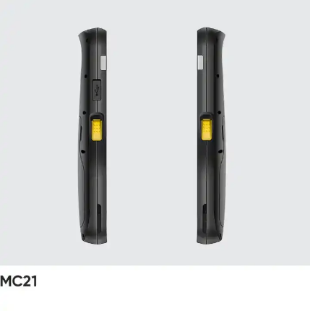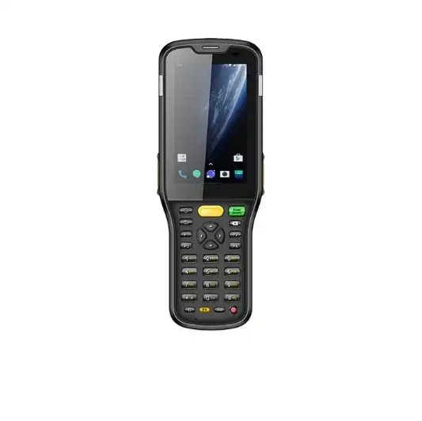

**Product Name:** GAOTek Barcode Scanner Handheld

**Product ID:** GAOTek-PERW-201

**Meta Description:** This Barcode Scanner Handheld has a screen size of 3.5inch , expansion slot of support up to 128 GB and a CPU of ARM cortex A35 quad-core 2.0.

**Technical Specifications:**

|  |  |
| --- | --- |
| **Private Mold** | Yes |
| **Processor Type** | Intel |
| **Screen Size** | 3.5inch |
| **Software development kit (SDK)** | Yes |
| **Communication** | 4G+WIFI+BT+GPS+NFC |
| **CPU** | ARM Cortex A53 Quad core 2.0 GHz |
| **Barcode scanner** | 1D or 2D Optional |
| **Expansion Slot** | Supports up to 128 GB Micro SD(TF) card |
| **Camera** | Rear 13 MP Auto focus with flash |
| **Chips** | M1 card (S50, S70), CPU card, NFC tags, etc. |
| **Sealing** | IP 65 |
| **Interface** | USB 2.0 Type C, OTG, supports Type C headphones |
| **Application** | Warehousing, Logistics, Retail, etc. |
| **Dimensions** | 7.35 in x 2.63 in x 0.96 in (186.6 mm x 66.7 mm x 24.3 mm) |
| **Weight** | 0.58 lb (0.285 kg) (device with battery) |

<https://www.alibaba.com/product-detail/Rugged-Industrial-PDA-With-Android-11_1600796825195.html?spm=a2700.galleryofferlist.p_offer.d_title.36dc59abPAUBAG&s=p>

**Prices:** 50 to 999 pieces US$498.00

1000 to 4999 pieces US$458.00

5000 to 19999 pieces US$398.00

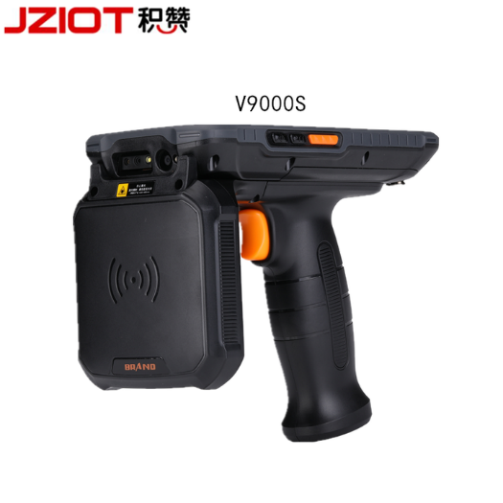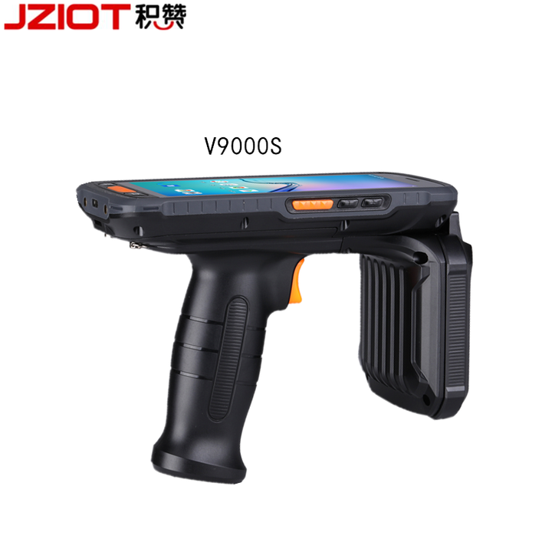>= 20000 pieces US$239.00

**Product Name:** GAOTek Rugged Industrial PDA

**Product ID:** GAOTek-PERW-202

**Overview:** GAOTek Rugged Industrial PDA **﻿**equipped with the high-performance module of Enfamil, it can meet a variety of working frequency bands, identify various RFID tags on the market, identify quickly, accurately and efficiently, and fully meet the requirements of asset management, clothing inventory, and vehicle management. The 13 million pixel color camera, which supports auto focusing and fill light, can easily capture clear and high-quality images.It has intelligent operation, multiple modes, and flexible selection. It can help you capture clear effects even in dark light environments.

**Technical Specifications:**

|  |  |
| --- | --- |
| **Operating System** | Android 11 |
| **Style** | Handheld Computer |
| **Memory Capacity** | 3G RAM+32G ROM |
| **Private Mold** | Private Mold |
| **Processor Type** | Processor Type |
| **Software development kit (SDK)** | Software development kit (SDK) |
| **Camera** | 13MP autofocus rear camera |
| **Battery** | 9000mAh |
| **GPS** | Support A-GPS |
| **RFID** | NFC(13.56MHZ),RFID Optional |
| **Screen size** | 5.5 Inch |
| **Bluetooth** | Bluetooth 5.0 |
| **Frequency** | 13.56 MHz |
| **Display** | 5.5 Inch IPS |
| **Power** | Li-on rechargeable, 9000 mAh |
| **Interface** | USB 2.0 Type-C , OTG |
| **Humidity** | 5 %RH to 95 %RH non condensing |
| **Operating Temperature** | -4 °F to 122 °F (-20 °C to 50 °C) |
| **Storage temp.** | -40 °F to 158 °F (-40 °C to 70 °C) |
| **Weight** | 1.28 lb (0.58 kg) |

<https://www.alibaba.com/product-detail/TS-901-Industrial-Pda-Android-Mobile_62059478540.html?spm=a2700.galleryofferlist.p_offer.d_title.36dc59abPAUBAG&s=p>

**Prices:** 1 to 49 pieces US$249.00

50 to 199 pieces US$239.00

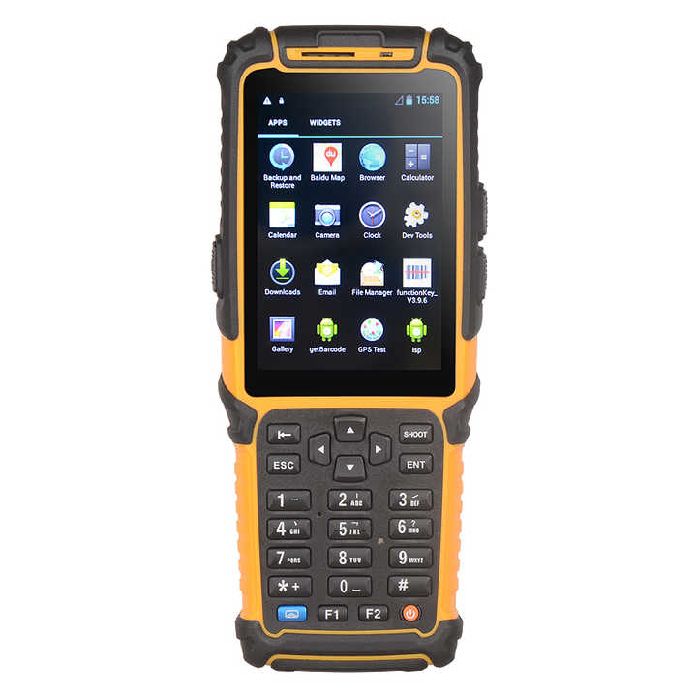>= 200 pieces US$229.00

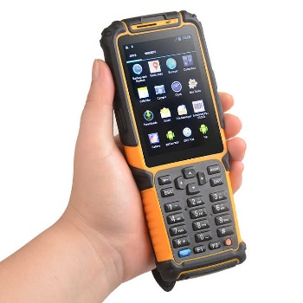

**Product Name:** GAOTek Industrial PDA Android Mobile

**Product ID:** GAOTek-PERW-203

**Meta Description:** This Industrial PDA Android Mobile has a battery voltage of 3.4 V to 4.2 V, cell voltage AC 100 V to 240 V,50Hz or 60Hz and a display of 3.5inch.

**Features:**

* Android 7.0 OS
* Memory:1 GB + 8 GB (SD/TF:32GB)
* IP64 industrial design,1.5m fall resistance
* Big battery capacity: 3800 mAH
* Barcode scanner: Symbol SE965; Symbol SE4750

**Technical Specifications:**

|  |  |
| --- | --- |
| **CPU Dominant frequency** | 1.2 GHz,Cortex A9 |
| **OS** | Android 7.0 |
| **Memory** | 8GB+1GB |
| **Display** | 3.5inch LCD,320 x 480TFT |
| **Touch** | Capacitive screen or Resistive Touch Panel |
| **Communication** | WIFI,GPS,Bluetooth,Radio,4G/WCDMA/EDGE/GSM,USB,UART |
| **External input** | 27 full keyboard input, audio input |
| **Output** | Stereo speaker output, video playback |
| **SD/TF** | 32 GB |
| **Standby Current** | below 3 mAh |
| **Working current** | 180 mAh |
| **Battery capacity** | 3800 MAH |
| **Battery voltage** | 3.4V to 4.2V |
| **Stand-by time** | over 1500 h |
| **Working hours** | over 15h |
| **Cell voltage** | AC 100 V to 240 V,50Hz or 60Hz |
| **Charging current** | 800mA |
| **Camera** | 5.0 Million Pixels. Take a picture  Camera shooting |
| **1D Barcode Bar code type** | UPC/EAN, Code 128,Code 39,Code 93,ode 11,Interleaved 2 of 5,Discrete 2 of 5,hinese 2 of 5,Codabar,MSI,RSS,Data Options, Serial Interface, Event Reporting |
| **1D Barcode Working current** | 50 mA |
| **2D Barcode Terminal brand** | Symbol SE4750 |
| **2D Barcode Bar code type** | Code39, PDF417, Data Matrix |
| **2D Barcode Working current** | 450 mA |
| **temperature** | 5 °F to 149 °F (-15℃ to 65℃) |
| **Storage temperature** | -4 °F to 176 °F (-20℃ to 80℃) |
| **Dimension** | 6.8 in x 2.5 in x 1.1 in (175 mm x 66 mm 30 mm) |
| **Weight** | 0.57 lb (0.23 kg) |

<https://www.alibaba.com/product-detail/Syncotek-Android-RFID-Reader-QR-Code_1600971172400.html?spm=a2700.galleryofferlist.normal_offer.d_title.36dc59abPAUBAG>

**Prices:** 1 to 99 pieces US$482.00

100 to 499 pieces US$453.00

500 to 999 pieces US$430.00

>= 1000 pieces US$401.00

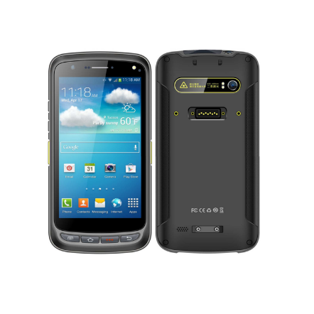

**Product Name:** GAOTek Scanner PDA Machine

**Product ID:** GAOTek-PERW-204

**Overview:** GAOTek Scanner PDA Machine is an Android rugged mobile computer. It features powerful processor, 8000mAh battery and superb UHF RFID capability. It can be equipped with Impinj E710 / R2000 linearly or circularly polarized antenna. That it can read tags in bulk from long distance enables it to be deployed in asset management, retail, warehousing, fleet management and etc.

**Technical Specifications:**

|  |  |
| --- | --- |
| **Display** | 5.2inchIPS LTPS 1920 x 1080 |
| **Touch Panel** | Corning Gorilla Glass, multi-touch panel, gloves and wet hands supported |
| **Power** | Li-ion, rechargeable, 8000 mAh |
| Standby: over 500 hours |
| Continuous use: over 12 hours (depending on user environment) |
| Charging time: 3 to 4 hours (with standard adaptor and USB cable) |
| **Expansion Slot** | 1 slot for Nano SIM card, 1 slot for Nano SIM or TF card |
| **Interfaces** | USB 2.0 Type-C, OTG, Type-C headphones supported |
| **Sensors** | Light sensor, proximity sensor, gravity sensor |
| **Notification** | Sound, LED indicator |
| **Audio** | 1 microphone; 1 speaker; receiver |
| **Keypad** | 4 front keys, 1 power key, 2 scan keys, 1 multifunctional  key |
| **Operating System** | Android 11; GMS, FOTA, SafeUEM supported.  Committed support for a future upgrade to Android 12,  13, and Android 14 pending feasibility |
| **CPU** | Cortex-A53 2.3 GHz Octa-core |
| **RAM+ROM** | 3 GB + 32 GB or 4 GB + 64 GB |
| **Expansion** | Supports up to 128 GB Micro SD card |
| **SDK** | Development Kit |
| **Language** | Java |
| **Tool** | Eclipse or Android Studio |
| **Tumble Specification** | 1000 mm x 50 mm. falls at room temperature |
| **Drop Specification** | Multiple 1.5 m / 4.9 ft. drops (at least 20 times) to the concrete  across the operating temperature range |
| **Sealing** | IP65 per IEC sealing specifications |
| **ESD** | ± 15KV air discharge, ± 8KV conductive discharge |
| **WLAN** | IEEE802.11, 2.4G/5G dual-band, internal  antenna |
| **Bluetooth** | Bluetooth 5.1 |
| **GNSS** | GPS or AGPS, GLONASS, BeiDou, Galileo, internal antenna |
| **Rear Camera** | Rear 13 MP Autofocus with flash |
| **Engine** | CM710-1 module based on Impinj E710  CM2000-1 module based on Impinj Indy R2000 |
| **Frequency** | 865 MHz to 868 MHz or 920 MHz to 925 MHz or 902 MHz to 928 MHz |
| **Protocol** | EPC C1 GEN2 or ISO18000-6C |
| **Antenna** | Circular polarization (4dBi), linear polarization(1.8dBi) |
| **Power** | 1 W (30 dBm, +5 dBm to +30 dBm adjustable) |
| 2 W Optional (33 dBm, for Latin America, etc. |
| **Fastest Read Rate** | 1200+ tags per sec (circular polarization) |
| **1D Linear Scanner** | Zebra: SE965; Honeywell: N4313 |
| **1D Symbologies** | UPC/EAN, Code128, Code39, Code93, Code11, Interleaved 2 of 5, Discrete 2 of 5, Chinese 2 of 5, Coda bar, MSI, RSS, etc. |
| **2D Imager Scanner** | Zebra: SE4710 / SE4750SR / SE4750MR or SE4750DP;  Honeywell: N6603 |
| **2D Symbologies** | PDF417, MicroPDF417, Composite, RSS, TLC-39, Data matrix, QR code, Micro QR code, Aztec, Maxi Code; Postal Codes: US Post Net, US Planet, UK Postal, Australian Postal, Japan Postal, Dutch Postal  (KIX), etc. |
| **Frequency** | 13.56 MHz |
| **Protocol** | ISO14443A/B, ISO15693, NFC-IP1, NFC-IP2, etc. |
| **Chips** | M1 card (S50, S70), CPU card, NFC tags, etc. |
| **Range** | 0.7 in to 1.2 in (20 mm to 4 mm) |
| **Standard** | AC Adaptor, USB Cable, etc. |
| **Optional** | Cradle, Holster , etc. |
| **Humidity** | 5%RH to 95%RH non condensing |
| **Operating Temp.** | -4 °F to 122°F (-20°C to 50 °C) |
| **Storage Temp.** | -40 °F to 158 °F (-40 °C to 70 °C) |
| **Dimensions** | 6.46 in x 3.15 in x 0.96 in (164.2 mm x 80.0 mm x 24.3 mm) |
| **Weight** | 1.43 lb (0.65 kg) |

<https://www.alibaba.com/product-detail/F9825-Handheld-PDAs-Android-11-Rugged_1600914088729.html?spm=a2700.galleryofferlist.normal_offer.d_title.36dc59abPAUBAG>

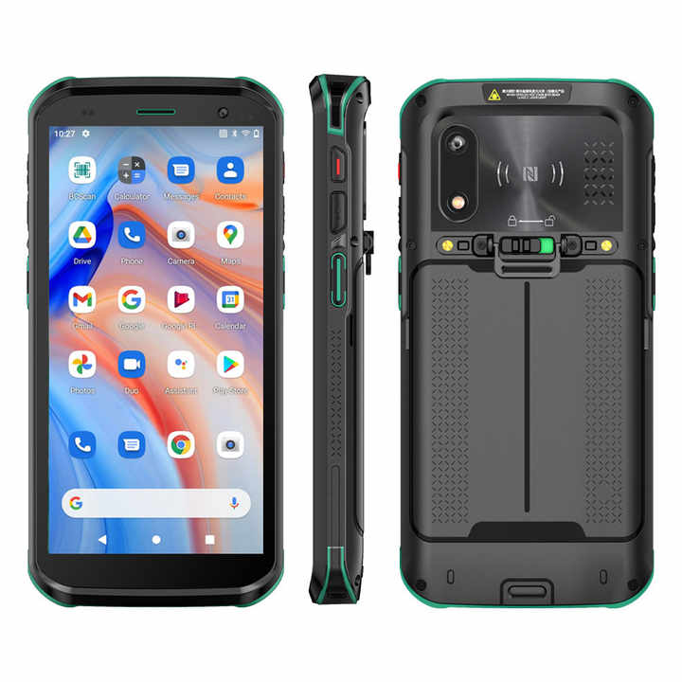**Price:** 1 piece US$239.00 to US$269.00



**Product Name:** GAOTek Industrial Logistics PDA

**Product ID:** GAOTek-PERW-205

**Meta Description:** This Industrial Logistics PDA has a power of 3.85 V or 5000 mAh, expansion slot of micro-SD card ,256 GB and a drop specification of 3.9inch.

**Technical Specifications:**

|  |  |
| --- | --- |
| **Display** | 5.5 in. HD+ industrial-grade IPS display |
| **Imager Window** | Corning® Gorilla® Glass |
| **Touch Panel** | Corning® Gorilla® Glass Capacitive touch panel, Support Water Gloves Touch Mode |
| **Backlight** | 450 NITS, LED |
| **Power** | Removable Rechargeable 3.85 V or 5000 mAh Li-ion battery |
| **Backup Power** | 5F Backup Super capacitor |
| **Expansion Slot** | Micro SD Card slot, 256 GB |
| **Expansion Ports** | 2 Pin Rear connection: Trigger key signal 4 Pin Bottom connection Charging port 5V or 3A, Support USB communication and OTG mode |
| **SIM Slots** | 2 x Nano SIM |
| **Notifications** | Audible tone; multi-color LEDs; Vibration |
| **Network Connections** | WWAN, Wi-Fi, Ethernet cradle |
| **Voice and Audio** | 1.5 W Speaker, Receiver, Dual Mic |
| **Keypad** | On-screen keypad and enterprise keyboard |
| **Buttons** | Programmable; Scan on each side; volume up/down; power; push-to-talk (PTT) |
| **Interface Ports** | Bottom USB 2.0 OTG to host or client (Type-C) |
| **CPU** | Octa-core, 2.0 GHz |
| **Operating System** | Android 11.0 |
| **RAM** | 3GB LPDDR3 (4GB Optional) |
| **Flash** | 32GB eMMC 5.1 (64GB Optional) |
| **Sensor** | Proximity Sensor Light Sensor Accelerometer、 Magnetometer、Gyroscope、Fingerprint Sensor |
| **Scanning** | Newland CM60 |
| **Camera** | Front 2 MP fixed focus; f/2.4 aperture Rear 5 MP auto focus; f/2.2 aperture; Flash LED |
| **NFC** | High RF output power; ISO15693、ISO14443A/B、MIFARE：Mifare S50,Mifare S70,Mifare UltraLight,Mifare Pro,Mifare Desfire  FeliCa Supported cards |
| **Positioning System** | GPS L1 with A-GPS: Glonass; BeiDou; Galileo |
| **Operating Channels** | CH1-CH13,CH36-CH165 |
| **Security and Encryption** | WEP,WPA/WPA2-PSK,WAPI,WAPI-PSK EAP: EAP-TLS,EAP-TTLS,PEAP-MSCHAPv2,PEAP-TLS, PEAP-GTC,PWD,SIM,AKA |
| **Fast Roam** | Supports 802.11r Fast Roam |
| **BT** | BT 4.1 ,BT Low Energy (BLE);secondary BT BLE beacon for finding lost (powered off) devices |
| **Communication Distance** | 3.9 in (Less than 100 mm) |
| **Sealing** | IP68 |
| **Drop Specification** | 59.6 in (1500 mm)(Concrete Surface) |
| **Electrostatic Discharge (ESD)** | +/-15 kV air discharge, +/-8 kV direct discharge |
| **Standard Accessories** | Adapter Charger x 1 USB Type-C cable x 1 Rechargeable Battery x 1 |
| **Optional Accessories** | 4-Slot battery Charger Single-Slot Charge+USB or Ethernet 5-Slot Share-Cradle Charge+Ethernet、Snap on Trigger Handle OTG Cable Hand Strap x 1 |
| **Humidity** | 5% to 95% non-condensing |
| **Operating Temp** | -4 °F to 140 °F (-20 ℃ to 60 ℃) |
| **Storage Temp** | 4 °F to 158 °F (-40 ℃ to 70 ℃) |
| **Dimensions** | 6.14 in x 2.95 in x 0.57 in (156 mm × 75 mm × 14.5 mm) |
| **Weight** | 0.59 lb (0.24 kg)(Batteries required, Depends on Product Configuration） |

<https://www.alibaba.com/product-detail/Rugged-industrial-logistic-Android-9-0_1600468069083.html?spm=a2700.galleryofferlist.normal_offer.d_title.36dc59abPAUBAG>

**Prices:** 1 to 99 pieces US$278.00

100 to 999 pieces US$258.00

>= 1000 pieces US$240.00

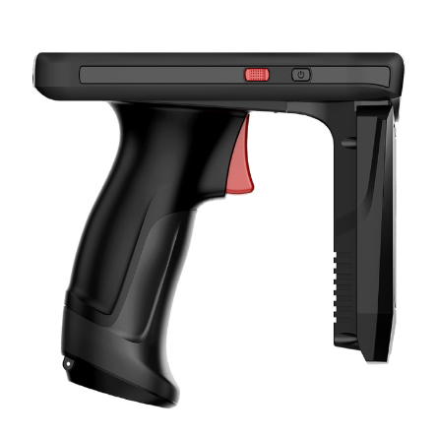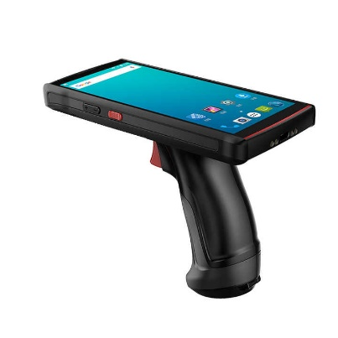

**Product Name:** GAOTek Reader mobile pda with GPS

**Product ID:** GAOTek-PERW-206

**Overview:** GAOTek Reader mobile pda with GPS is an Android-based rugged mobile computer. With its fast 4G connectivity and powerful octa-core processor as well as the  
comprehensive data capture options, including NFC(optional), best-in-class 1D/2D barcode scanning, high-resolution camera and GPS, you can find this easy-to-deploy device an exceptionally valuable helper for your workers to increase their efficiency and productivity. With its highly customizable ability, enterprises can deploy this single device in many areas, including logistics, warehouse management, asset tracking, fleet management, health care and etc.

**Technical Specifications:**

|  |  |
| --- | --- |
| **Display and Touch Panel** | 5.7inch WVGA (720 x 1440), Rugged touch capacitive touch panel |
| **Power** | Main battery: Li-ion, rechargeable, 5000mAh |
| **Expansion Slot** | 2 x PSAM (Optional): ISO7816 protocol, 1 SIM, 1 MicroSD (TF) slot |
| **Interfaces** | Type -C USB |
| **AC Adapter** | Input: 100V to 240V, 50-60Hz, 0.29 A ,Output:5V, 2A |
| **CPU** | Cortex-A53 Octa-core 64-bit 2.0GHz high-performance processor |
| **Storage** | RAM+ROM: 3 GB + 32 GB |
| **Operating System** | Android 9.0 |
| **Humidity** | 5 %RH to 95%RH non condensing |
| **SDK** | Software Development Kit |
| **Language and Tool** | Java, Eclipse or Android Studio |
| **Blue Tooth** | Support BT2.0 +EDR or 3.0 +HS or 4.1+HS, Transmission distance is 5-10m |
| **GNSS** | GPS or AGPS, internal antenna |
| **Resolution** | Rear 13 MP autofocus camera with flash+ Front 2MP camera |
| **Frequency** | 13.56 MHz |
| **Protocol** | ISO14443A or B, ISO15693, NFC-IP1, NFC-IP2, etc. |
| **Engine** | R2000-1, based on impinj Indy R2000 |
| **Agreement** | Standard agreement of EPC GEN2 or ISO18000-6C or 6B |
| **Power** | 1 W (30dbm support to adjust from 5dbm to 30 dbm) |
| **Operating Temp.** | -4 °F to 122°F (-20 °C to 55 °C) |
| **Storage Temp.** | -4 °F to 158 °F (-25 °C to 70 °C) |
| **Dimension** | 6.2 in x 4.8 in x 2.9 in (159 mm x 124 mm x 75 mm) |
| **Weight** | 1.58 lb (0.48 kg) |

<https://www.alibaba.com/product-detail/1D-2D-Android-Barcode-Scanner-PDA_1600433560179.html?spm=a2700.galleryofferlist.normal_offer.d_title.36dc59abPAUBAG>

**Prices:** 1 to 9 pieces US$355.00

>= 10 pieces US$329.00

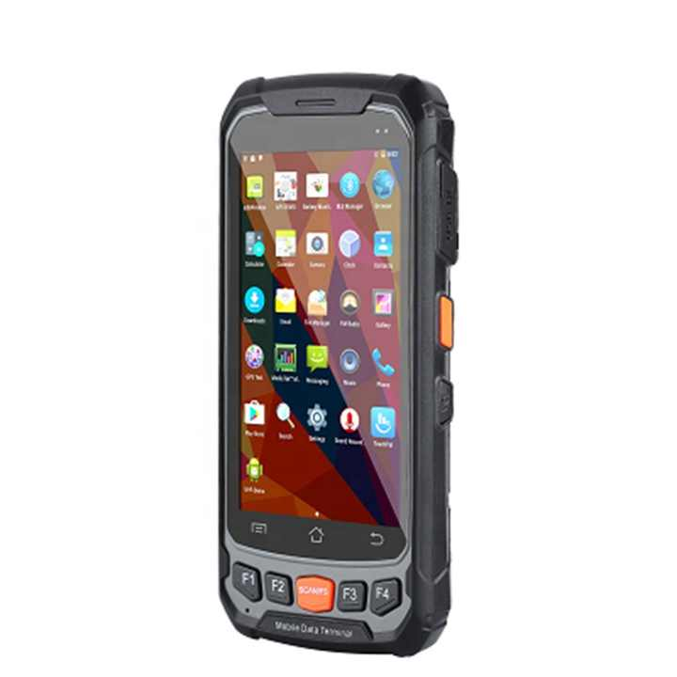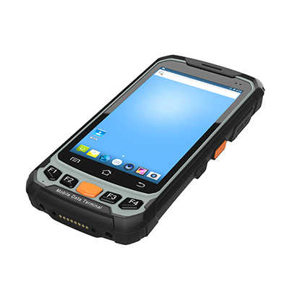

**Product Name:** GAOTek

**Product ID:** GAOTek-PERW-207

**Meta Description:** This Industrial Logistics PDA has a battery of 3.8 V or 4750 mAh, Frequency of 125 KHz or 134.2 KHz and a humidity of 5 % RH to 95 % RH.

**Technical Specifications:**

|  |  |  |
| --- | --- | --- |
| **Display** | 4.7 inch Gorilla Glass 3 9H TFT-LCD(720x1280)touch screen with backlight | |
| **Backlight** | LED backlight | |
| **Keypads** | 3 TP keys, 5 function keys, 4 side buttons | |
| **Expansions** | 2 PSAM, 1 SIM, 1 TF | |
| **Battery** | Rechargeable li-ion polymer, 3.8V, 4750mAh | |
| **CPU** | Quad A53 1.3GHz quad-core | |
| **Operating System** | Android 7.0 | |
| **Storage** | 2GB RAM, 16GB ROM, MicroSD (max 128GB expansion) | |
| **Drop Specifications** | 59.6 in (1500 mm) drop to concrete across the operating temperature range | |
| **Sealing** | IP65, IEC compliance | |
| **ESD** | ±15kv air discharge, ±8kv direct discharge | |
| **SDK** | Handheld-Wireless Software Development Kit | |
| **Language** | Java | |
| **Environment** | Android Studio or Eclipse | |
| **GPS** | GPS(embedded A-GPS), accuracy of 5 m | |
| **1D laser engine** | N4313 |  |
| **Symbologies** | All major 1D barcodes |  |
| **2D CMOS Imager** | Newland EM3296 or EM3396 |  |
| **Symbologies** | PDF417,MicroPDF417,Composite,RSS, TLC-39, Data matrix, QR code, Micro QR code, Aztec, Maxi Code, Postal Codes, US Post Net, US Planet, UK Postal, Japan Postal, Dutch Postal. etc. |  |
| **Resolution** | 8.0 megapixel | |
| **Lens** | Auto-focus with LED flash | |
| **Frequency** | 125 KHz or 134.2 KHz (FDX-B/HDX) |  |
| **Protocol** | ISO 11784&11785 |  |
| **Frequency** | 13.56 MHz |  |
| **Protocol** | ISO 14443A 15693 |  |
| **R/W Range** | 2cm to 8cm |  |
| **Frequency** | 865 MHz to 868 MHz or 920 MHz to 25 MHz |  |
| **Protocol** | EPC C1 GEN2 or ISO 18000-6C |  |
| **Antenna Gain** | Circular antenna(2dBi) |  |
| **Protocol** | ISO 7816 | |
| **Baud rate** | 9600, 19200, 38400,43000, 56000, 57600, 115200 | |
| **Slot** | 2 slots(maximum) | |
| **Humidity** | 5 %RH to 95 %RH (non-condensing) | |
| **Storage Temp.** | -4 °F to 158 °F (-20 ℃ to 70 ℃) | |
| **Operating Temp.** | -4 °F to 158 °F (-20 ℃ to 50 ℃) | |
| **Dimension** | 162 mm x78 mm x 22mm | |
| **Weight** | 0.77 lb (0.35 kg) (including battery wrist strap) | |